Nadar Saraswathi College of Engineering and Technology
Department of Electronics and Communication Engineering
IOT Assignment
Topic : Assignment on temperature and humidity sensing and alarm automation using python
Name: TAMILARASAN .M
Code:-
import random while(True):
a=random.randint(10,99) b=random.randint(10,99) if(a>35 and b>60):
print("high temprature and humidity of:",a,b,"%","alarm is on") elif(a<35 and b<60):
print("Normal temprature and humidity of:",a,b,"%","alarm is off") break

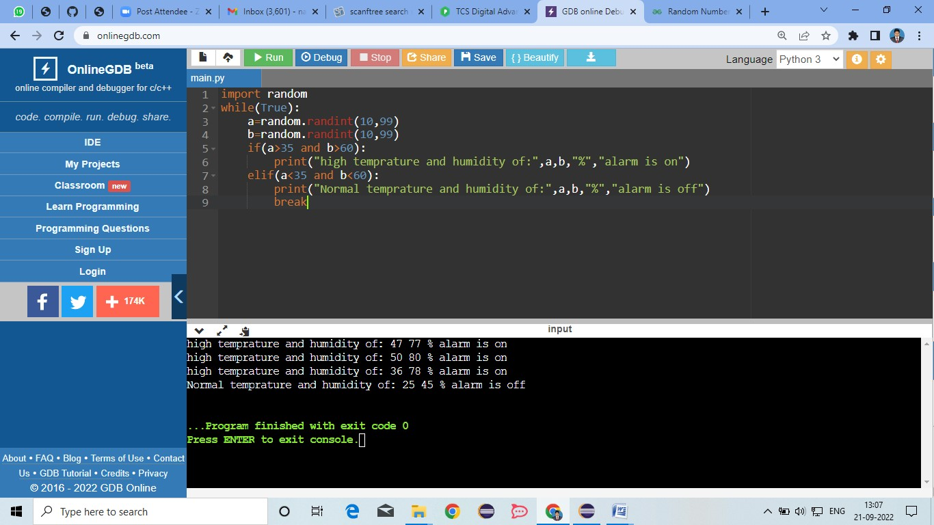
Output:
-

**********************************************************

